MAPPING TROUBLES
A Mini project report
Submitted in fulfillment of the requirements

For the award of degree of

BACHELOR OF TECHNOLOGY
IN
COMPUTER SCIENCE AND ENGINEERING

BY
S.PRADEEP KUMAR (13QH1A0552)
E.PRASHANTH (13QH1A0511)
RAJEEV KUMAR (13QH1A0542)
T.PREMCHARAN (13QH1A0555)

Under the Esteemed Guidance of
Mrs. B. V. RAMANA
Assistant professor


DEPARTMENT OF COMPUTER SCIENCE AND ENGINEERING
HOLY MARY INSTITUTE OF TECHNOLOGY
(Approved by AICTE, New Delhi, Affiliated to JNTUH)
Hyderabad-500090

2016-2017

MAPPING TROUBLES
By

S.PRADEEP KUMAR (13QH1A0552)
E.PRASHANTH (13QH1A0511)
RAJEEV KUMAR (13QH1A0542)
T.PREMCHARAN (13QH1A0555)

Guide
Mrs. B. V. RAMANA
Assistant professor

DEPARTMENT OF COMPUTER SCIENCE AND ENGINEERING
HOLY MARY INSTITUTE OF TECHNOLOGY
(Approved by AICTE, New Delhi, Affiliated to JNTUH)
Bogaram (vill), Keesara (Mndl), RangaReddy(DIST)-501301

2016-2017

HOLY MARY INSTITUTE OF TECHNOLOGY
(Approved by AICTE, New Delhi, Affiliated to JNTUH)
Hyderabad-500090
2013-2014
DEPARTMENT OF COMPUTER SCIENCE AND ENGINEERING

CERTIFICATE

This is to certify that the Project report entitled “MAPPING TROBULES” is being submitted by the following student in partial fulfillment of the requirements for the award of degree of bachelor of technology in computer science and engineering from Jawaharlal Nehru Technological university Hyderabad, Telangana is record of bonafide work carried out during the academic year 2016-2017.
S.PRADEEP KUMAR (13QH1A0552)
E.PRASHANTH (13QH1A0511)
RAJEEV KUMAR (13QH1A0542)
T.PREMCHARAN (13QH1A0555)

INTERNAL GUIDE HOD OF THE DEPARTMENT

Mrs. B.V.RAMANA Mr. G.SOMA SEKHAR
Assistant professor Associate professor
Department of CSE Department of CSE

ACKNOWLEDGEMENT

The successful completion of any task is not possible without proper suggestions guidance and environment. Combination of these three factors acts like backbone to my project titled “MAPPING TROUBLES”.
We express our sincere thanks to our guide, Department of Computer Science and Engineering, Mrs. B. V. RAMANA her valuable suggestions during our course period, timely help, guidance and providing us with most essential materials required for the completion of this work.
We express our since thanks to our HOD, Department of Computer Science and Engineering. Mr. G.SOMASEKHAR for his valuable suggestions during our course period, timely help, guidance and providing us with the most essential materials required for the completion of this work.
We would like to thank our principal, Dr. B.S REDDAPPA for providing support and simulating environment. We would like express my gratitude to the management of college name for providing me a pleasant environment and excellent and excellent laboratory facilities.
We special thanks to project coordinator Mrs. B.V. RAMANA and all the faculty of CSE Department for giving the required information in doing my project work. Not to forget, I thank all the non-teaching staff, and my friends who had directly or indirectly helped and supported me in completing my project in time.
We are thankful to all teaching and non-teaching staff of the Department of Computer Science & Engineering for the cooperation given for the successful completion of my project.
Finally we wish to convey my gratitude to my parents who fostered all the requirements and facilities that I need.

S.PRADEEP KUMAR (13QH1A0552)
E.PRASHANTH (13QH1A0511)
RAJEEV KUMAR (13QH1A0542)
T.PREMCHARAN (13QH1A0555)

ABSTRACT

Generally, every village has its problems like primary education, people’s health, Government policies, water problems and more. These problems are shared and known to people who are living in particular village. The development of this new web-enabled system objective is to provide solutions to the problems of every village. In this new system individual members would add problems about any village which are faced and known to user by selecting a particular village. By using the new system, problems of all villages are grouped together and made available to everyone who will read this problems and may respond to these problems. Members can read problems of every village and may add problems to system. Members, who want response to the problems of particular village, will communicate with the admin and discuss about further proceedings. The system will providing the features like chatting and mailing for communication between admin and members, it will helps to provide response to problems. Members can also send the additional information about villages as reports to the admin. Admin develops the villages with donors helps. In this new system the members like donors can give their valuable information to the admin so that the admin can check their progress of maintenance.

INDEX

- INTRODUCTION
Existing System
Proposed System

- LITERATURE SURVEY

2.1Survey of technology

- REQUIREMENT SPECIFICATION

3.1 Required Specification
3.2 Functional Requirements

4. DESIGN

4.1 UML Diagram

5. IMPLEMENTATION
Modules
Code

6. TESTING

6.1 Test Plan
6.2 Test Case

7. OUTPUTS

8. CONCLUSION

9. FUTURE ENHANCEMENT

10 BIBILIOGRAPHY

LIST OF FIGURES

Figure Name of the figure page number

1 Admin Use Case Diagram i

2 User Use Case Diagram ii

3 Admin Activity Diagram iii

4 User Activity Diagram iv

5 Class Diagram v

6 Collaboration Diagram vi

7 Sequence Diagram ix

1.INTRODUCTION:
Keeping in view the fact that Rural Roads are vital to economic growth and measures for poverty alleviation in the village. The Programme seeks to provide connectivity to all unconnected habitations in the rural areas.

The Rural Development in India is one of the most important factors for growth of the Indian economy. The Ministry of Rural Development in India is an apex body to develop the rural sector implementing several developmental programmes and projects. It needs data related to rural areas at mandal / village level. This research work has been carried out to develop the web based “Mapping Troubles System” as a model at village level.

Rural development is a process of qualitative and quantitative changes to improve conditions in rural regions. Such a process needs to be an integrated programme where all aspects of rural life should be taken into account. The rural underprivileged must receive Non-formal Education essentially to become literate and employable in better jobs. Generally the non-formal stream of education can be divided into three groups: (1) literacy for non school going children, (2) vocational education and family welfare programmes for youth and (3) functional literacy and self-employment programme for adults.

Mapping Troubles, programmes give prior attention to rural development. It has its own role to play in development It can provide the knowledge with which we can develop the kind of socio-cultural settings that will met the pressing demands of our time. Development is a process of liberating the individual and society with fullest utilization of physical as well as human resources. Education and more specifically Mapping Troubles is viewed as a component within the existing socio-economic-political framework.

Mapping Troubles implies both the economic betterment of people as well as greater social transformation. Increased participation of people in the rural development programmes, decentralization of planning, better enforcement of land reforms and greater access to credit are envisaged for providing the rural people with better prospects

Mapping Troubles through its multifarious programmes of literacy, numeracy, functionality and social awareness and raising the quality of life of an individual through changes in attitudes, habits and ways of personal life. Functional literacy and extension through Mapping Troubles programmes simultaneously contribute to higher productivity through improvement in the existing techniques of production and quantitative and qualitative development in human resources.

Nevertheless, vocational training and literacy work must continue to develop as a secondary endeavor, as the Literate and employed can be better expected to develop social awareness, desirability and usefulness.
The development of education among women is the main instrument through which we can narrow down the prevailing social inequality and accelerate the process of economic and political changes in the status of women.

It has great significance for a country like India where majority of the population, around 65% of the people, live in rural areas. The present strategy of rural development in India mainly focuses on poverty alleviation, better livelihood opportunities, provision of basic amenities and infrastructure facilities through innovative programmes of wage and self-employment

Rural development in India has witnessed several changes over the years in its emphasis, approaches, strategies and programmes. It has assumed a new dimension and perspectives as a consequence. Rural development can be richer and more meaningful only through the participation of clienteles of development. Just as implementation is the touchstone for planning, people's participation is the centre-piece in rural development. People's participation is one of the foremost pre-requisites of development process both from procedural and philosophical perspectives. For the development planners and administrators it is important to solicit the participation of different groups of rural people, to make the plans participatory.

The rural economy is an integral part of the overall Indian economy. As majority of the poor reside in the rural areas, the prime goal of rural development is to improve the quality of life of the rural people by alleviating poverty through the instrument of self-employment and wage employment programmes, by providing community infrastructure facilities such as drinking water, electricity, road connectivity, health facilities, rural housing and education and promoting decentralization of powers to strengthen the Panchayati raj institutions etc

Being the nodal application for most of the development and welfare activities in the rural areas, the Mapping Troubles plays a pivotal role in the overall development strategy of the country. The vision and mission of the Ministry is sustainable and inclusive growth of rural India through a multipronged strategy for eradication of poverty by increasing livelihoods opportunities, providing social safety net and developing infrastructure for growth. This is expected to improve quality of life in rural India and to correct the developmental imbalances, aiming in the process, to reach out to most disadvantaged sections of the society.

Mapping Troubles implies both the economic betterment of people as well as greater social transformation. Increased participation of people in the rural development programmes, decentralization of planning, better enforcement of land reforms and greater access to credit are envisaged for providing the rural people with better prospects.
Being the nodal Department for most of the development and welfare activities in the rural areas, the Department of Rural Development plays a vital role in the overall development strategy of the State. The vision and mission of the Department is sustainable and inclusive growth of rural Tripura through a multipronged strategy for eradication of poverty by increasing livelihoods opportunities, providing social safety net and developing infrastructure for growth
EXISTING SYSTEM:
There are many village development Systems available in today’s market. The systems will only focus on one village and their problems. There will be no direct interaction between users and donors. There is no system that will display the problems of the village directly into the web. This system cannot provide the information sharing by 24X7. If any information is need to be share between group members it is done either manually or by mailing. The collecting of problems of a village is done by group members only. Maintaining information about every village is a big task. Only face to face communication is possible between the group members and village people. It maintains only problems list about every village and no additional information about villages is unavailable. The existing system is semi automated at which the information is stored in the form of excel sheets in disk drivers. In the existing system it is difficult to know the problem of every village and provide a solution to them. People who want to help the villages must contact the village persons to know problems. It is difficult to club the problems. In the existing system compared to computer work manual work is high. Here there is no way for a village person to submit a problem directly to the village problem list. It takes too much of time to read the problems of every village. In existing system only village problems are available in the record of villages. No additional information is available about villages like primary education, weather conditions, population, tourist places and more. If any information sharing to the group members or voluntaries who works to develop the village is through mailing is more critical in this system.

PROPOSED SYSTEM WITH FEATURE:
The development of this new web-enabled system named as “Mapping Troubles” objective is to provide the solution of the existing system. By using this new system, we can fully automate the entire the process of the current system. The new system is a charity group of professionals those who want to voluntarily contribute in their village/town’s development. Issues like primary education, people’s health, government policies awareness and availability of basic facilities/ infrastructure are on main focus among others. Being a web-enabled system, the process can be accessed across the world over net. This system also providing the features like Chatting , Mailing between the members.
The System “Mapping Troubles” solves all these problems. In the present system we developed an Application that will focus on all villages and their problems. MTS will display the problems faced by the villages. The existing system is semi automated at which the information is stored in the form of excel sheets in disk drivers. In the existing system

2. LITERATURA SURVEY

Before starting this project we had done lots of re-search on different websites and text books. After successful completion of re-search we have decided to develop this project. Based on .NET Technology.

2.1 .Net Framework

The purpose of testing is a technology that supports building and running the next generation of applications and XML Web services. The .NET Framework is designed to fulfill the following objectives:
- To provide a consistent object-oriented programming environment whether object code is stored and executed locally, executed locally but Internet-distributed, or executed remotely.
- To provide a code-execution environment that minimizes software deployment and versioning conflicts.
- To provide a code-execution environment that promotes safe execution of code, including code created by an unknown or semi-trusted third party.
- To provide a code-execution environment that eliminates the performance problems of scripted or interpreted environments.
- To make the developer experience consistent across widely varying types of applications, such as Windows-based applications and Web-based applications.
- To build all communication on industry standards to ensure that code based on the .NET Framework can integrate with any other code.
The .NET Framework consists of the common language runtime and the .NET Framework class library. The common language runtime is the foundation of the .NET Framework. You can think of the runtime as an agent that manages code at execution time, providing core services such as memory management, thread management, and remoting, while also enforcing strict type safety and other forms of code accuracy that promote security and robustness. In fact, the concept of code management is a fundamental principle of the runtime. Code that targets the runtime is known as managed code, while code that does not target the runtime is known as unmanaged code. The class library is a comprehensive, object-oriented collection of reusable types that you can use to develop applications ranging from traditional command-line or graphical user interface (GUI) applications to applications based on the latest innovations provided by ASP.NET, such as Web Forms and XML Web services.
The .NET Framework can be hosted by unmanaged components that load the common language runtime into their processes and initiate the execution of managed code, thereby creating a software environment that can exploit both managed and unmanaged features. The .NET Framework not only provides several runtime hosts, but also supports the development of third-party runtime hosts.
For example, ASP.NET hosts the runtime to provide a scalable, server-side environment for managed code. ASP.NET works directly with the runtime to enable ASP.NET applications and XML Web services.
Internet Explorer is an example of an unmanaged application that hosts the runtime (in the form of a MIME type extension). Using Internet Explorer to host the runtime enables you to embed managed components or Windows Forms controls in HTML documents. Hosting the runtime in this way makes managed mobile code possible, but with significant improvements that only managed code can offer, such as semi-trusted execution and isolated file storage.
The following illustration shows the relationship of the common language runtime and the class library to your applications and to the overall system. The illustration also shows how managed code operates within a larger architecture.
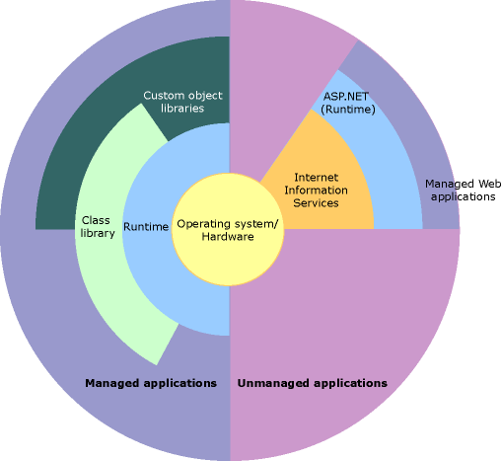
Figure 2.1: .NET Framework in context

Features of the Common Language Runtime
The common language runtime manages memory, thread execution, code execution, code safety verification, compilation, and other system services. These features are intrinsic to the managed code that runs on the common language runtime.
With regards to security, managed components are awarded varying degrees of trust, depending on a number of factors that include their origin (such as the Internet, enterprise network, or local computer). This means that a managed component might or might not be able to perform file-access operations, registry-access operations, or other sensitive functions, even if it is being used in the same active application.
The runtime enforces code access security. For example, users can trust that an executable embedded in a Web page can play an animation on screen or sing a song, but cannot access their personal data, file system, or network. The security features of the runtime thus enable legitimate Internet-deployed software to be exceptionally feature rich.
The runtime also enforces code robustness by implementing a strict type-and-code-verification infrastructure called the common type system (CTS). The CTS ensures that all managed code is self-describing. The various Microsoft and third-party language compilers generate managed code that conforms to the CTS. This means that managed code can consume other managed types and instances, while strictly enforcing type fidelity and type safety.
In addition, the managed environment of the runtime eliminates many common software issues. For example, the runtime automatically handles object layout and manages references to objects, releasing them when they are no longer being used. This automatic memory management resolves the two most common application errors, memory leaks and invalid memory references.
The runtime also accelerates developer productivity. For example, programmers can write applications in their development language of choice, yet take full advantage of the runtime, the class library, and components written in other languages by other developers. Any compiler vendor who chooses to target the runtime can do so. Language compilers that target the .NET Framework make the features of the .NET Framework available to existing code written in that language, greatly easing the migration process for existing applications.
While the runtime is designed for the software of the future, it also supports software of today and yesterday. Interoperability between managed and unmanaged code enables developers to continue to use necessary COM components and DLLs.
The runtime is designed to enhance performance. Although the common language runtime provides many standard runtime services, managed code is never interpreted. A feature called just-in-time (JIT) compiling enables all managed code to run in the native machine language of the system on which it is executing. Meanwhile, the memory manager removes the possibilities of fragmented memory and increases memory locality-of-reference to further increase performance.
Finally, the runtime can be hosted by high-performance, server-side applications, such as Microsoft SQL Server and Internet Information Services (IIS). This infrastructure enables you to use managed code to write your business logic, while still enjoying the superior performance of the industry's best enterprise servers that support runtime hosting.

.NET Framework Class Library
The .NET Framework class library is a collection of reusable types that tightly integrate with the common language runtime. The class library is object oriented, providing types from which your own managed code can derive functionality. This not only makes the .NET Framework types easy to use, but also reduces the time associated with learning new features of the .NET Framework. In addition, third-party components can integrate seamlessly with classes in the .NET Framework.
For example, the .NET Framework collection classes implement a set of interfaces that you can use to develop your own collection classes. Your collection classes will blend seamlessly with the classes in the .NET Framework.
As you would expect from an object-oriented class library, the .NET Framework types enable you to accomplish a range of common programming tasks, including tasks such as string management, data collection, database connectivity, and file access. In addition to these common tasks, the class library includes types that support a variety of specialized development scenarios. For example, you can use the .NET Framework to develop the following types of applications and services:
- Console applications.
- Windows GUI applications (Windows Forms).
- Windows Presentation Foundation (WPF) applications.
- ASP.NET applications.
- Windows services.
- Service-oriented applications using Windows Communication Foundation (WCF).
- Workflow-enabled applications using Windows Workflow Foundation (WF).

2.1.2 Visual C#

C# is an elegant and type-safe object-oriented language that enables developers to build a variety of secure and robust applications that run on the .NET Framework. You can use C# to create Windows client applications, XML Web services, distributed components, client-server applications, database applications, and much, much more. Visual C# provides an advanced code editor, convenient user interface designers, integrated debugger, and many other tools to make it easier to develop applications based on the C# language and the .NET Framework.
C# syntax is highly expressive, yet it is also simple and easy to learn. The curly-brace syntax of C# will be instantly recognizable to anyone familiar with C, C++ or Java. Developers who know any of these languages are typically able to begin to work productively in C# within a very short time. C# syntax simplifies many of the complexities of C++ and provides powerful features such as nullable value types, enumerations, delegates, lambda expressions and direct memory access, which are not found in Java. C# supports generic methods and types, which provide increased type safety and performance, and iterators, which enable implementers of collection classes to define custom iteration behaviors that are simple to use by client code. Language-Integrated Query (LINQ) expressions make the strongly-typed query a first-class language construct.
As an object-oriented language, C# supports the concepts of encapsulation, inheritance, and polymorphism. All variables and methods, including the Main method, the application's entry point, are encapsulated within class definitions. A class may inherit directly from one parent class, but it may implement any number of interfaces. Methods that override virtual methods in a parent class require the override keyword as a way to avoid accidental redefinition. In C#, a struct is like a lightweight class; it is a stack-allocated type that can implement interfaces but does not support inheritance.
In addition to these basic object-oriented principles, C# makes it easy to develop software components through several innovative language constructs, including the following:
- Encapsulated method signatures called delegates, which enable type-safe event notifications.
- Properties, which serve as accessors for private member variables.
- Attributes, which provide declarative metadata about types at run time.
- Inline XML documentation comments.
- Language-Integrated Query (LINQ) which provides built-in query capabilities across a variety of data sources.

If you have to interact with other Windows software such as COM objects or native Win32 DLLs, you can do this in C# through a process called "Interop." Interop enables C# programs to do almost anything that a native C++ application can do. C# even supports pointers and the concept of "unsafe" code for those cases in which direct memory access is absolutely critical.
The C# build process is simple compared to C and C++ and more flexible than in Java. There are no separate header files, and no requirement that methods and types be declared in a particular order. A C# source file may define any number of classes, structs, interfaces, and events.

.NET Framework Platform Architecture for C#
C# programs run on the .NET Framework, an integral component of Windows that includes a virtual execution system called the common language runtime (CLR) and a unified set of class libraries. The CLR is the commercial implementation by Microsoft of the common language infrastructure (CLI), an international standard that is the basis for creating execution and development environments in which languages and libraries work together seamlessly.
Source code written in C# is compiled into an intermediate language (IL) that conforms to the CLI specification. The IL code and resources, such as bitmaps and strings, are stored on disk in an executable file called an assembly, typically with an extension of .exe or .dll.
When the C# program is executed, the assembly is loaded into the CLR, which might take various actions based on the information in the manifest. Then, if the security requirements are met, the CLR performs just in time (JIT) compilation to convert the IL code to native machine instructions. The CLR also provides other services related to automatic garbage collection, exception handling, and resource management. The following diagram illustrates the compile-time and run-time relationships of C# source code files, the .NET Framework class libraries, assemblies, and the CLR.
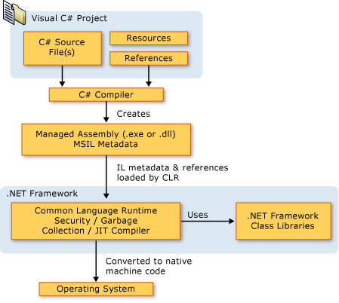
Figure 2.2: Architecture of C# in .Net

2.1.3 ASP.Net

ASP.NET is a unified Web development model that includes the services necessary for you to build enterprise-class Web applications with a minimum of coding. ASP.NET is part of the .NET Framework, and when coding ASP.NET applications you have access to classes in the .NET Framework. You can code your applications in any language compatible with the common language runtime (CLR), including Microsoft Visual Basic and C#. These languages enable you to develop ASP.NET applications that benefit from the common language runtime, type safety, inheritance, and so on.
If you want to try ASP.NET, you can install Visual Web Developer Express using the Microsoft Web Platform Installer, which is a free tool that makes it simple to download, install, and service components of the Microsoft Web Platform. These components include Visual Web Developer Express, Internet Information Services (IIS), SQL Server Express, and the .NET Framework. All of these are tools that you use to create ASP.NET Web applications. You can also use the Microsoft Web Platform Installer to install open-source ASP.NET and PHP Web applications.

The Three Flavors of ASP.NET: Web Forms, MVC, and Web Pages
ASP.NET offers three frameworks for creating web applications: ASP.NET Web Forms, ASP.NET MVC, and ASP.NET Web Pages. All three frameworks are stable and mature, and you can create great web applications with any of them.
Each framework targets a different audience or type of application. Which one you choose depends on a combination of your web development experience, what framework you’re most comfortable with, and which is the best fit for the type of application you’re creating. All three frameworks will be supported, updated, and improved in future releases of ASP.NET.

ASP.NET Web Forms (.aspx pages)
The Web Forms framework targets developers who prefer declarative and control-based programming, such as Microsoft Windows Forms (WinForms) and WPF/XAML/Silverlight. It offers a WYSIWYG designer-driven (drag-and-drop) development model, so it's popular with developers looking for a rapid application development (RAD) environment for web development. If you’re new to web programming and are familiar with the traditional Microsoft RAD client development tools (for example, for Visual Basic and Visual C#), you can quickly build a web application without having expertise in HTML and JavaScript.
Web Forms works well for small teams of Web developers and designers who want to take advantage of the large number of components available for rapid application development. In general, creating a Web Forms application requires less programming effort than creating the same application by using the ASP.NET MVC framework. The components (the Page class, controls, and so on) are tightly integrated and usually require less code than ASP.NET MVC applications. However, Web Forms is not just for rapid application development. There are many complex commercial apps and app frameworks built on top of Web Forms.

ASP.NET MVC
ASP.NET MVC targets developers who are interested in patterns and principles like test-driven development, separation of concerns, inversion of control (IoC), and dependency injection (DI). This framework encourages separating the business logic layer of a web application from its presentation layer.
By dividing the application into the model (M), views (V), and controllers (C), ASP.NET MVC can make it easier to manage complexity in larger applications. With ASP.NET MVC, you can have multiple teams working on a web site because the code for the business logic is separate from the code and markup for the presentation layer — developers can work on the business logic while designers work on the markup and JavaScript that is sent to the browser.
With ASP.NET MVC, you work more directly with HTML and HTTP than in Web Forms. Web Forms tends to hide some of that by mimicking the way you would program a WinForms or WPF application. For example, Web Forms can automatically preserve state between HTTP requests, but you have to code that explicitly in MVC. The MVC model enables you to take complete control over exactly what your application is doing and how it behaves in the web environment.
MVC was designed to be extensible, providing power developers the ability to customize the framework for their application needs. In addition, the ASP.NET MVC source code is available under an OSI license.

ASP.NET Web Pages (.cshtml and .vbhtml files)
ASP.NET Web Pages targets developers who want a simple web development story, along the lines of PHP. In the Web Pages model, you create HTML pages and then add server-based code to the page in order to dynamically control how that markup is rendered. Web Pages is specifically designed to be a lightweight framework, and it's the easiest entry point into ASP.NET for people who know HTML but might not have broad programming experience — for example, students or hobbyists. It's also a good way for web developers who know PHP or similar frameworks to start using ASP.NET.
Like Web Forms, Web Pages is oriented toward rapid development. Web Pages provides components called helpers that you can add to pages and that let you use just a few lines of code to perform tasks that would either be tedious or complex. For example, there are helpers to display database data, add a Twitter feed, log in using Facebook, add maps to a page, and so on.

ASP.NET Compiler
All ASP.NET code is compiled, which enables strong typing, performance optimizations, and early binding, among other benefits. Once the code has been compiled, the common language runtime further compiles ASP.NET code to native code, providing improved performance.
ASP.NET includes a compiler that will compile all your application components including pages and controls into an assembly that the ASP.NET hosting environment can then use to service user requests.

2.1.4 SQL SERVER

SQL Server is a client / server Relational Database Management System (RDBMS) which has been developed by Microsoft and is made up several different client and server programs that make up the entire product.
SQL Server Database Engine (Server)
SQL Server's database engine is the primary server application of the SQL server package. Its main functions are:
- Provide reliable storage
- Rows of data are stored as pages, each 8kb in size.
- Provide a means to rapidly access the data; this is done through utilizing indexes both clustered and non-clustered to search for data, which removes the need for all data to be scanned from the database tables.
- Ensure consistent access to the data; Consistent access basically means only allowing one client to modify/changing the data at any one time
- Implement security; Microsoft SQL Server has multiple security levels Server Level, database level and database object level. Access to the server can be controlled by a Username or password or through Windows security in LAN/Networked environment.
- Enforce data integrity; ensure the data stays consistent.
The ITS Systems Database team offers standards-based, professionally managed SQL Server database systems including hardware, software, and system administration for University of Texas customers. The Microsoft SQL Server database servers may be used for websites, commercial applications, and custom applications designed and built by the customer. The central Microsoft SQL Server database servers are shared to minimize cost and ensure efficient use of the service resources. This service provides three database environments to support the full application development life cycle. The included environments are Development, Quality Assurance (QA), and Production. This service includes database/system administration, database backups and recovery, and monitoring.
Features
- Microsoft SQL Server 2012 environment with Always On Availability Group configuration
- 10 gigabytes of storage space on the central Microsoft SQL Server database servers
- Daily production backups (at minimum) with a four-week retention
- Ability to safely store Confidential Data in databases
- Access to the ITS Systems Microsoft SQL Server team for advice and troubleshooting

In the Fully Managed infrastructure, ITS owns, manages, and supports the SQL Server hardware and host server software resources. The Fully Managed ITS shared SQL Server service is recommended for departments, colleges, or other groups that require SQL Server database service. ITS provides the hardware, software, and staff resources to manage the central SQL Server infrastructure. It is also recommended for those who may be using Confidential Data in their databases.

REQUIREMENTS SPECIFICATION
Hardware requirements:
- Processor : I3 Processor
- Hard Disk : 1 TB.
- RAM : 4 GB
- Processor Speed : 1.54GHZ

Software requirements:
- Operating system : - Windows 8.
- Coding Language : ASP.NET,C# Programming
- Data Base : SQL Server

Software specifications

Software specifications of the system that is used in the project is

- Operating system: WINDOWS 8

- Front end: MICROSOFT VISUAL STUDIO 2012: Microsoft Visual Studio is an Integrated Development Environment from Microsoft .It can be used to develop console and graphical user interface applications along with windows forms applications , websites, web applications and web services in both native code together with managed code for all platforms supported by Microsoft Windows,.NET framework,.NET compact Framework and Microsoft Silver light .It also supports the c# that we use to create web site.

- Back end: SQL SERVER 2008 R2: In this SQL Server Management Studio is a software application first launched with the Microsoft SQL Server 2005 that is used for configuring, managing, and administering all components with in Microsoft SQL Server.

- Microsoft Office Word 2007: We use Microsoft Office Word 2007 to do our documentation of this project. This is very important for us to do this project. We have use the feature of text box to draw the hierarchical chart to describe the various of subsystem, modules and sub-modules in the system. It also uses to check our spelling and grammar and justify all the words to make our document look nicer.

4. DESIGN
4.1 UML DIAGRAMS

The Unified Modeling Language (UML) is a graphical language for visualizing, specifying, constructing and documenting of a software intensive system. The UML gives a standard way to standard way to write a system blueprints, covering conceptual things, such as classes written in a specified programmed language, database schemas and reusable software components.
There are types of diagrams
- Class Diagram
- Object Diagram
- Use case Diagram
- Sequence Diagram
- Collaboration Diagram
- State chart Diagram
- Activity Diagram
- Component Diagram
- Deployment Diagram

4.1.1 Use Case Diagram
- Use case is a description of set of sequence of actions that a system performs that yields an observable results. These are important in organizing the behaviors of a system.
- Use case is used to structure the behavioral things in a model.
- A Use case is realized by collaboration.
- Graphically , a use case is rendered as a ellipse with solid lines, usually including only its name
ACTOR- also referred to as roles. Name and stereotype of an actor can be changed in its properties lab
Use Cases- these can have extension points.
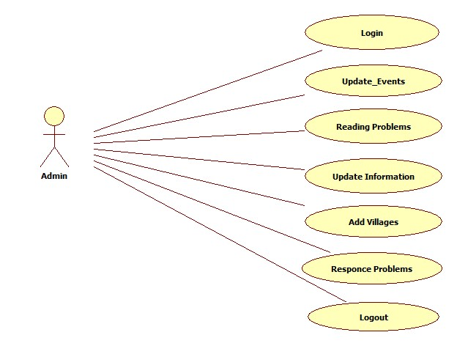
Admin Use Case Diagram

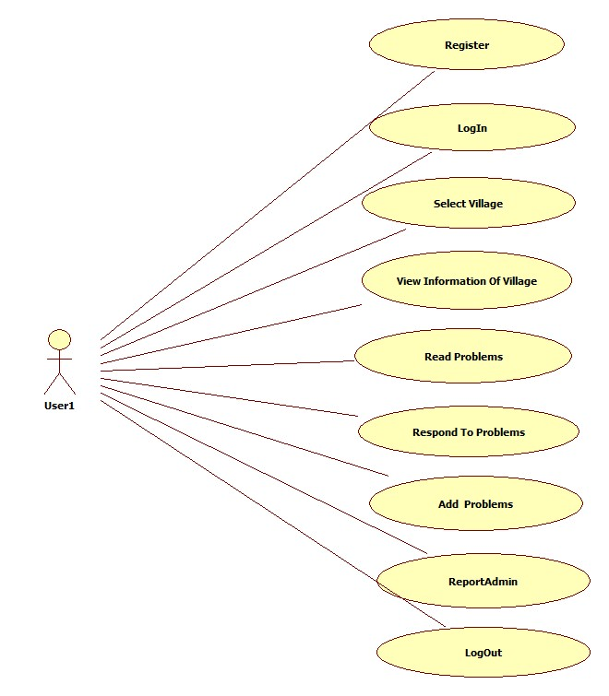
User Use Case Diagram

4.1.2 CLASS DIAGRAM

The class diagram is a static diagram. It represents the static view of an application. Class diagram is not only used for visualizing , describing documenting different aspects of a system but also for constructing executable code of the software application. The class diagram describes the attributes and operations of a class and also the constraints imposed on the system. The class diagrams are widely used in the modeling of object oriented system because they are the only UML diagrams which can be mapped directly with object oriented languages.
The class diagram shows a collection of classes, interfaces, associations, collaboration and constraints. It is also known as structural diagram.
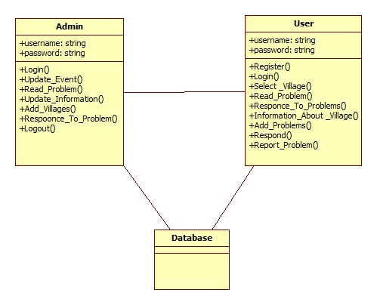

Class Diagram

4.1.3 SEQUENCE DIAGRAM

A Sequence diagram is an interaction diagram that emphasizes the time ordering of messages. A Sequence diagram shows a set of objects and messages sent and received by those objects. The objects are typically named or anonymous instances of classes, but may also represent instances of other thing such as collaboration, components and nodes. These are used to illustrate the dynamic view of a system. It is isomorphic, which means taking any one of them in to consideration, and can be transformed to another.

4.1.4 COLLABORATION DIAGRAM

A Collaboration diagram is an interaction diagram that emphasizes the structural organization of the objects that send and receive messages. Collaboration diagrams are isomorphic, meaning that you can take one and transform it in to another
Graphically, collaboration is rendered as an ellipse with dashed lines, usually including only its name.

4.1.5 ACTIVITY DIAGRAMS

Activity diagrams are graphical representations of work flows of stepwise activities and actions with support for choice, iteration and concurrency. In the Unified Modeling Language, activity diagrams are intended to model both computational and organizational processes. Activity diagrams show the overall flow of control.

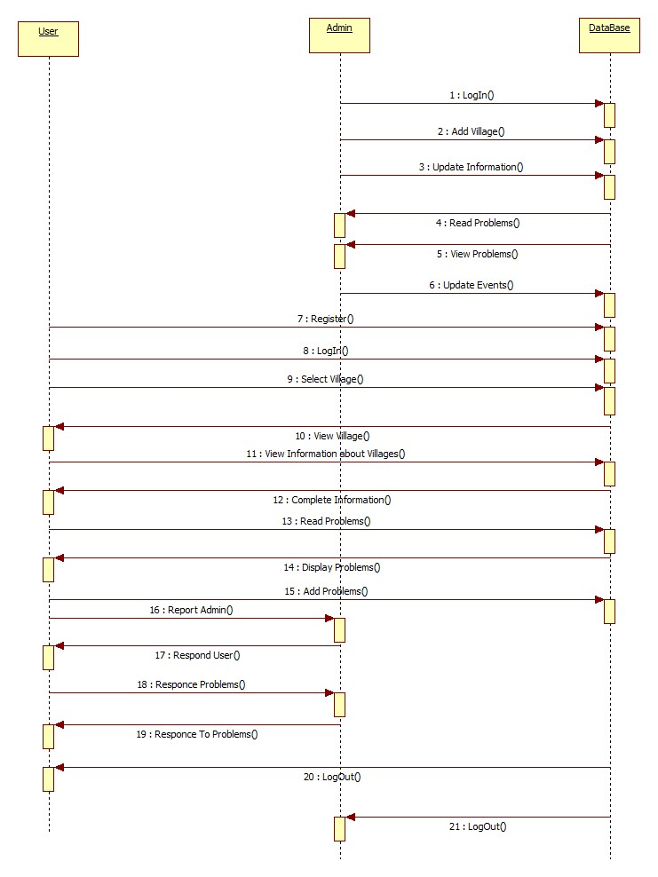

Sequence Diagram

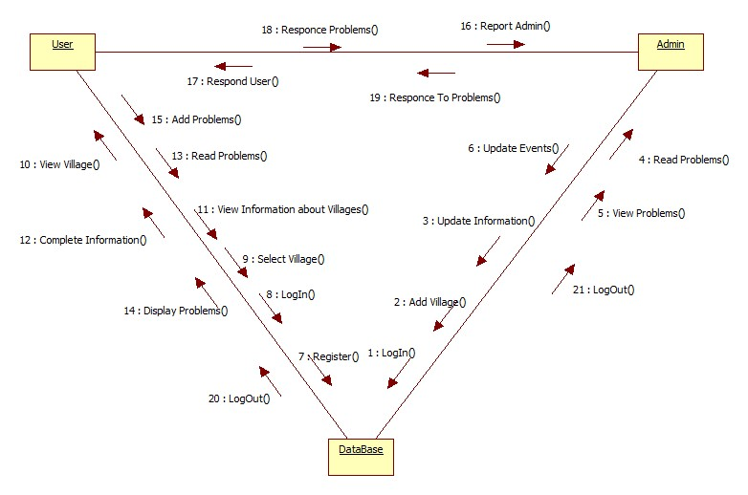

Collaboration Diagram

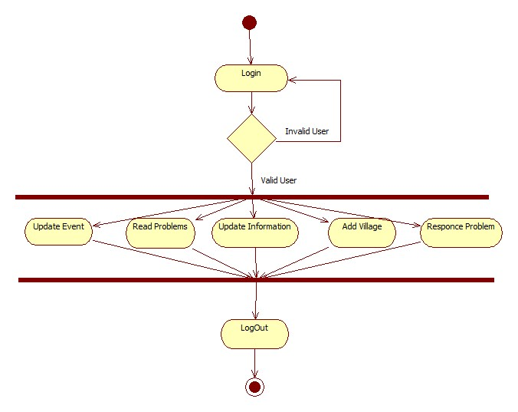
Admin Activity Diagram
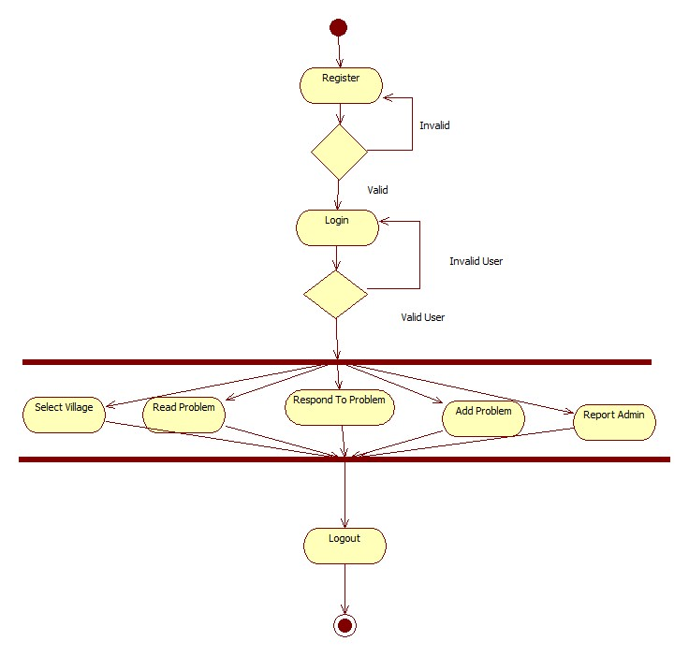
User Activity Diagram

CODE:
MAIN HOME
using System;
using System.Collections.Generic;
using System.Linq;
using System.Web;
using System.Web.UI;
using System.Web.UI.WebControls;

public partial class Home : System.Web.UI.Page
{
protected void Page_Load(object sender, EventArgs e)
{

}
}
REGISTRATION
using System;
using System.Collections.Generic;
using System.Linq;
using System.Web;
using System.Web.UI;
using System.Web.UI.WebControls;

public partial class Register : System.Web.UI.Page
{
Class1 obj = new Class1();
protected void Page_Load(object sender, EventArgs e)
{

}
protected void Button2_Click(object sender, EventArgs e)
{
try
{
String qry = "insert into Regi values('"+ txtfirst.Text + "', '"+ txtsur.Text + "','"+ txtuser.Text + "','"+ txtpass.Text + "','"+ txtcal.Text + "','" +RadioButtonList1.SelectedItem.Text + "','" +txtloc.Text + "','" +txtpin.Text + "' )";
int i = obj.inupdel(qry);
if (i > 0)
{
Response.Write("<Script>alert('Registration Succesfully completed')</script>");
txtfirst.Text = txtsur.Text = txtuser.Text = txtpass.Text = txtcnfpass.Text = txtcal.Text = txtloc.Text = RadioButtonList1.SelectedItem.Text = txtpin.Text = "";
}
else
{
Response.Write("<Script>alert('Registration not yet completed')</script>");
}
}
catch (Exception ex)
{
}
}

LOGIN
using System;
using System.Collections.Generic;
using System.Linq;
using System.Web;
using System.Web.UI;
using System.Web.UI.WebControls;
public partial class Login : System.Web.UI.Page
{
Class1 obj = new Class1();
protected void Page_Load(object sender, EventArgs e)
{
}
protected void Lgn_Click(object sender, EventArgs e)
{
try
{
if (dlistlogin.SelectedItem.Text == "User")
{
String qry = "select * from Regi where username='" +txtuname.Text+ "' and password='" +txtpword.Text+ "'";
DataSet ds = obj.select(qry);
if (ds.Tables[0].Rows.Count > 0)
{
Session["Id"] = ds.Tables[0].Rows[0][0].ToString();
Session["username"] = ds.Tables[0].Rows[0][3].ToString();
Response.Redirect("~/User/Home.aspx");
}
else
{
Response.Write("<script>alert('Invalid UserName or Password')</script>");
}
else if (dlistlogin.SelectedItem.Text == "Admin")
{
if (txtuname.Text == "Admin" && txtpword.Text == "Admin")
{
Response.Redirect("~/Admin/Home.aspx");
}
else
{
Response.Write("<script>alert('Invalid UserName or Password')</script>");
}

catch (Exception ex)
{
}

FORGOT PASS WORD
using System;
using System.Collections.Generic;
using System.Linq;
using System.Web;
using System.Web.UI;
using System.Web.UI.WebControls;

public partial class ForgotPassword : System.Web.UI.Page
{
Class1 obj = new Class1();
protected void Button2_Click(object sender, EventArgs e)
{
String qry = "select * from Regi where username='" +txtfp.Text+"'" ;
DataSet ds = obj.select(qry);
if (ds.Tables[0].Rows.Count > 0)
{
Session["username"] = ds.Tables[0].Rows[0][3].ToString();
Session["password"] = ds.Tables[0].Rows[0][4].ToString();
Response.Redirect("RecoverPassword.aspx");
}
else
{
Response.Write("<script>alert('Invalid UserName !! Please check Your Username once')</script>");
}
}
}
RECOVER PASSWORD
using System;
using System.Collections.Generic;
using System.Linq;
using System.Web;
using System.Web.UI;
using System.Web.UI.WebControls;
public partial class RecoverPassword : System.Web.UI.Page
{
protected void Page_Load(object sender, EventArgs e)
{
txtfp.Text = Session["username"].ToString();
txtpass.Text = Session["password"].ToString();}

protected void Button2_Click(object sender, EventArgs e)
{
Response.Redirect("Home.aspx");
}
}
USER HOME
using System;
using System.Collections.Generic;
using System.Linq;
using System.Web;
using System.Web.UI;
using System.Web.UI.WebControls;

public partial class User_Home : System.Web.UI.Page
{
protected void Page_Load(object sender, EventArgs e)
{
lblmsg.Text = Session["username"].ToString();
if (!IsPostBack)
{
load();
}
}
Class1 obj = new Class1();
public void load()
{
try
{ string qry2 = "select * from Regi where username='" + Session["username"].ToString() + "'";
DataSet ds = obj.select(qry2);
if (ds.Tables[0].Rows.Count > 0)
{
username.Text = ds.Tables[0].Rows[0][3].ToString();
}
else
{
Response.Write("<script>alert('There is No Data')</script>");
}
}
catch (Exception ex)
{
Response.Write("<script>alert('" + ex.Message + "')</script>");
}
}
protected void ImageButton1_Click(object sender, ImageClickEventArgs e)
{
try
{
string qry = "update Regi set firstname='" + firstname.Text + "',lastname='" + lastname.Text + "',username='" + username.Text + "',password='" + password.Text + "', dob='" +dob.Text + "',location='"+location.Text+"',pincode='"+pincode.Text+"' where username='"+ Session["username"].ToString()+"'";
int i = obj.inupdel(qry);
if (i > 0)
{
Response.Write("<script>alert('Updated Succesfully')</script>");
}
}

catch (Exception ex)
{
Response.Write("<script>alert('" + ex.Message + "')</script>");
}
}
protected void LinkButton7_Click(object sender, EventArgs e)
{
firstname.ReadOnly = false;
}

}
USER SELECT VILLAGE
using System;
using System.Collections.Generic;
using System.Data;
using System.Linq;
using System.Web;
using System.Web.UI;
using System.Web.UI.WebControls;

public partial class User_SelectVillage : System.Web.UI.Page
{
protected void Page_Load(object sender, EventArgs e)
{
if (!IsPostBack)
{
UpdatePanel1.Visible = false;
UpdatePanel2.Visible = false;
}}

Class1 obj = new Class1();
protected void ddlss_SelectedIndexChanged(object sender, EventArgs e)
{
if (ddlss.SelectedItem.Text == "AndhraPradesh")
{
ddlsd.Items.Clear();
ddlsd.Items.Add("--Select");
ddlsd.Items.Add("Krishna");
ddlsd.Items.Add("Anathapur");
ddlsd.Items.Add("EastGodavari");
}
else if (ddlss.SelectedItem.Text == "Telangana")
{
ddlsd.Items.Clear();
ddlsd.Items.Add("--Select");
ddlsd.Items.Add("Nalgonda");
ddlsd.Items.Add("Warangal");
ddlsd.Items.Add("Karimnagar");

}

else if (ddlss.SelectedItem.Text == "Karnataka")
{
ddlsd.Items.Clear();
ddlsd.Items.Add("--Select");
ddlsd.Items.Add("Kolar");
ddlsd.Items.Add("Raichur");
ddlsd.Items.Add("Haveri");

}
}

protected void ddlsd_SelectedIndexChanged(object sender, EventArgs e)
{
if (ddlss.SelectedItem.Text == "AndhraPradesh")
{
if (ddlsd.SelectedItem.Text == "Krishna")
{
ddlsv.Items.Clear();
ddlsv.Items.Add("Gudivada");
ddlsv.Items.Add("Nuzvid");
ddlsv.Items.Add("Vijayawada");
ddlsv.Items.Add("Gannavaram");
}
else if (ddlsd.SelectedItem.Text == "Anathapur")
{
ddlsv.Items.Clear();
ddlsv.Items.Add("Alamuru");
ddlsv.Items.Add("Obulampally");
ddlsv.Items.Add("Kurumamidi");
ddlsv.Items.Add("Malliraeddypalli");
}
else if (ddlsd.SelectedItem.Text == "EastGodavari")
{
ddlsv.Items.Clear();
ddlsv.Items.Add("Amalapuram");
ddlsv.Items.Add("Rajamandry");
ddlsv.Items.Add("Tuni");
ddlsv.Items.Add("Thallarevu");
}
}
else if (ddlss.SelectedItem.Text == "Telangana")
{
if (ddlsd.SelectedItem.Text == "Nalgonda")
{
ddlsv.Items.Clear();
ddlsv.Items.Add("Aler");
ddlsv.Items.Add("Bhongir");
ddlsv.Items.Add("Vemulakonda");
ddlsv.Items.Add("Yadadri");
}
else if (ddlsd.SelectedItem.Text == "Warangal")
{
ddlsv.Items.Clear();
ddlsv.Items.Add("Jangon");
ddlsv.Items.Add("Bhupalapally");
ddlsv.Items.Add("Hanmakonda");
ddlsv.Items.Add("Parakala");
}
else if (ddlsd.SelectedItem.Text == "Karimnagar")
{
ddlsv.Items.Clear();
ddlsv.Items.Add("Kancharla");
ddlsv.Items.Add("Siricilla");
ddlsv.Items.Add("Ramagundam");
ddlsv.Items.Add("Gopalpur");
}

}
else if (ddlss.SelectedItem.Text == "Karnataka")
{
if (ddlsd.SelectedItem.Text == "Kolar")
{
ddlsv.Items.Clear();
ddlsv.Items.Add("Ahanya");
ddlsv.Items.Add("Mulluru");
ddlsv.Items.Add("PalarNagar");
ddlsv.Items.Add("Tayalur");
}
else if (ddlsd.SelectedItem.Text == "Raichur")
{
ddlsv.Items.Clear();
ddlsv.Items.Add("Jalahalli");
ddlsv.Items.Add("Galaga");
ddlsv.Items.Add("Arkera");
ddlsv.Items.Add("Hosur");
}
else if (ddlsd.SelectedItem.Text == "Haveri")
{
ddlsv.Items.Clear();
ddlsv.Items.Add("Kaginale");
ddlsv.Items.Add("Hanagal");
ddlsv.Items.Add("Belur");
ddlsv.Items.Add("Kalasur");
}

protected void lnkbtn2_Click(object sender, EventArgs e)
{
if (ddlsv.SelectedItem.Text == "" || ddlsd.SelectedItem.Text == "")
{
Response.Write("<script>alert('Please Select Village or City !!')</script>");
}
else
{
UpdatePanel1.Visible = false;
string qry = "select * from vlgprblm where village ='" + ddlsv.SelectedItem.Text + "'";
DataSet ds = obj.select(qry);
if (ds.Tables[0].Rows.Count > 0)
{
GridView1.DataSource = ds;
GridView1.DataBind();
UpdatePanel3.Visible = true;
}
else
{
Response.Write("<script>alert('No Data Found !!')</script>");
}
}
}
protected void Button2_Click(object sender, EventArgs e)
{
try
{

String qry = "insert into vlgprblm values('" + Session["username"].ToString() + "','" + ddlss.SelectedItem.Text + "','" + ddlsd.SelectedItem.Text + "','" + ddlsv.SelectedItem.Text + "','" + txtsub.Text + "','" + txtprblm.Text + "')";
int i = obj.inupdel(qry);
if (i > 0)
{
String message ="alert('New Problem Succesfuuly added')";
ScriptManager.RegisterClientScriptBlock((sender as Control),this.GetType(),"alert",message,true);

}
else
{
String message = "alert('New Problem Not Yet added')";
ScriptManager.RegisterClientScriptBlock((sender as Control), this.GetType(), "alert", message, true);
}
}
catch (Exception ex)
{
}
}
protected void Button4_Click(object sender, EventArgs e)
{
try
{
String qry = "insert into prblmresponce values('" + Session["Id"].ToString() + "','" + Session["username"].ToString() + "','" + ddlss.SelectedItem.Text + "','" + ddlsd.SelectedItem.Text + "','" + ddlsv.SelectedItem.Text + "','" + txtsub.Text + "','" + restxt.Text + "')";
int i = obj.inupdel(qry);
if (i > 0)
{
String message = "alert('Problems Respond Succesfuuly Added')";
ScriptManager.RegisterClientScriptBlock((sender as Control), this.GetType(), "alert", message, true);
}
else
{
String message = "alert('Problems Respond Not Yet Added')";
ScriptManager.RegisterClientScriptBlock((sender as Control), this.GetType(), "alert", message, true);
}
}
catch (Exception ex)
{
}
}
PAST EVENTS
using System;
using System.Collections.Generic;
using System.Data;
using System.Linq;
using System.Web;
using System.Web.UI;
using System.Web.UI.WebControls;

public partial class User_PastEventst : System.Web.UI.Page
{
Class1 obj=new Class1();
protected void Page_Load(object sender, EventArgs e)
{
if (!IsPostBack)
{
bind();
}
}
public void bind()
{
String qry = "select * from events";
DataSet ds = obj.select(qry);
if (ds.Tables[0].Rows.Count > 0)
{
gridviewfeedbck.DataSource = ds;
gridviewfeedbck.DataBind();
}
else
{
}
}

ADMIN ADD VILLAGE
using System;
using System.Collections.Generic;
using System.Linq;
using System.Web;
using System.Web.UI;
using System.Web.UI.WebControls;
public partial class Admin_AddVillage : System.Web.UI.Page
{
Class1 obj = new Class1();
protected void Page_Load(object sender, EventArgs e)
{
}
protected void btnsub_Click(object sender, EventArgs e)
{

try
{
String qry = "insert into vlglist values('" + ddlss.Text + "','" + ddlsd.Text + "','" + ddlsv.Text + "','" + txt1.Text + "')";
int i = obj.inupdel(qry);
if (i > 0)
{
Response.Write("<Script>alert('New village Information Succesfully Added')</script>");
}
else
{
Response.Write("<Script>alert('No information added')</script>");
}
}
catch (Exception ex)
{
}
}
protected void ddlsd_SelectedIndexChanged(object sender, EventArgs e)
{
{
if (ddlss.SelectedItem.Text == "AndhraPradesh")
{
if (ddlsd.SelectedItem.Text == "Krishna")
{
ddlsv.Items.Clear();
ddlsv.Items.Add("Gudivada");
ddlsv.Items.Add("Nuzvid");
ddlsv.Items.Add("Vijayawada");
ddlsv.Items.Add("Gannavaram");
}
else if (ddlsd.SelectedItem.Text == "Anathapur")
{
ddlsv.Items.Clear();
ddlsv.Items.Add("Alamuru");
ddlsv.Items.Add("Obulampally");
ddlsv.Items.Add("Kurumamidi");
ddlsv.Items.Add("Malliraeddypalli");
}
else if (ddlsd.SelectedItem.Text == "EastGodavari")
{
ddlsv.Items.Clear();
ddlsv.Items.Add("Amalapuram");
ddlsv.Items.Add("Rajamandry");
ddlsv.Items.Add("Tuni");
ddlsv.Items.Add("Thallarevu");
}
}
else if (ddlss.SelectedItem.Text == "Telangana")
{
if (ddlsd.SelectedItem.Text == "Nalgonda")
{
ddlsv.Items.Clear();
ddlsv.Items.Add("Aler");
ddlsv.Items.Add("Bhongir");
ddlsv.Items.Add("Vemulakonda");
ddlsv.Items.Add("Yadadri");
}
else if (ddlsd.SelectedItem.Text == "Warangal")
{
ddlsv.Items.Clear();
ddlsv.Items.Add("Jangon");
ddlsv.Items.Add("Bhupalapally");
ddlsv.Items.Add("Hanmakonda");
ddlsv.Items.Add("Parakala");
}
else if (ddlsd.SelectedItem.Text == "karimnagar")
{
ddlsv.Items.Clear();
ddlsv.Items.Add("Kancharla");
ddlsv.Items.Add("Siricilla");
ddlsv.Items.Add("Ramagundam");
ddlsv.Items.Add("Gopalpur");
}

}
else if (ddlss.SelectedItem.Text == "Karnataka")
{
if (ddlsd.SelectedItem.Text == "Kolar")
{
ddlsv.Items.Clear();
ddlsv.Items.Add("Ahanya");
ddlsv.Items.Add("Mulluru");
ddlsv.Items.Add("PalarNagar");
ddlsv.Items.Add("Tayalur");
}
else if (ddlsd.SelectedItem.Text == "Raichur")
{
ddlsv.Items.Clear();
ddlsv.Items.Add("Jalahalli");
ddlsv.Items.Add("Galaga");
ddlsv.Items.Add("Arkera");
ddlsv.Items.Add("Hosur");
}
else if (ddlsd.SelectedItem.Text == "Haveri")
{
ddlsv.Items.Clear();
ddlsv.Items.Add("Kaginale");
ddlsv.Items.Add("Hanagal");
ddlsv.Items.Add("Belur");
ddlsv.Items.Add("Kalasur");
}

}
}
}
protected void ddlsv_SelectedIndexChanged(object sender, EventArgs e)
{ }
}
ADMIN READ PROBLEM
using System;
using System.Collections.Generic;
using System.Data;
using System.Linq;
using System.Web;
using System.Web.UI;
using System.Web.UI.WebControls;

public partial class Admin_ReadProblems : System.Web.UI.Page
{
Class1 obj = new Class1();
protected void Page_Load(object sender, EventArgs e)
{
if (!IsPostBack)
{
bind();
}
}
public void bind()
{
String qry = "select * from vlgprblm";
DataSet ds = obj.select(qry);
if (ds.Tables[0].Rows.Count > 0)
{
gvrp.DataSource = ds;
gvrp.DataBind();
}
else
{
}
}
ADMIN RESPOND PROBLEM
using System;
using System.Collections.Generic;
using System.Data;
using System.Linq;
using System.Web;
using System.Web.UI;
using System.Web.UI.WebControls;

public partial class Admin_ResponseProblems : System.Web.UI.Page
{
Class1 obj = new Class1();
protected void Page_Load(object sender, EventArgs e)
{
if (!IsPostBack)
{
bind();
UpdatePanel1.Visible = false;
}
}
protected void gridviewfeedbck_Click(object sender, ImageClickEventArgs e)
{
ImageButton btn = (ImageButton)sender;
GridViewRow gr = (GridViewRow)btn.NamingContainer;
Label lblid = (Label)gr.FindControl("Label1");
string qry = "delete from prblmresponce where vid='" + lblid.Text + "'";
int i = obj.inupdel(qry);
if (i > 0)
{
Response.Write("<script>alert('Unwanted Responce Deleted Succesfully')</script>");
bind();
}
else
{
Response.Write("<script>alert('Unwanted Problem Not Yet Deleted')</script>");
}
}
public void bind()
{
String qry = "select * from prblmresponce";
DataSet ds = obj.select(qry);
if (ds.Tables[0].Rows.Count > 0)
{
gvrp.DataSource = ds;
gvrp.DataBind();
}
else
{
Response.Write("<script>alert('No Data Found !!')</script>");
}
}
protected void Button2_Click(object sender, EventArgs e)
{
try
{
String qry = "insert into uchat values('" + txtuid.Text + "','" + txtunm.Text + "','" + txtmsg.Text + "')";
int i = obj.inupdel(qry);
if (i > 0)
{
Response.Write("<script>alert('New Meassage sended to inbox Successfuly!!')</script>");
}
else
{
Response.Write("<script>alert(' Meassge Not Send')</script>");
}
}
catch (Exception ex)
{
}
}
ADMIN VIEW VILLAGE
using System;
using System.Collections.Generic;
using System.Data;
using System.Linq;
using System.Web;
using System.Web.UI;
using System.Web.UI.WebControls;

public partial class Admin_ViewVillages : System.Web.UI.Page
{
Class1 obj = new Class1();
protected void Page_Load(object sender, EventArgs e)
{
if (!IsPostBack)
{
bind();
}
}
public void bind()
{
String qry = "select * from vlglist";
DataSet ds = obj.select(qry);
if (ds.Tables[0].Rows.Count > 0)
{
gridviewfeedbck.DataSource = ds;
gridviewfeedbck.DataBind();
}
else
{
}
protected void gridviewfeedbck_Click(object sender, ImageClickEventArgs e)
{
ImageButton btn = (ImageButton)sender;
GridViewRow gr = (GridViewRow)btn.NamingContainer;
Label lblid = (Label)gr.FindControl("Label1");
string qry = "delete from vlglist where vid='" + lblid.Text + "'";
int i = obj.inupdel(qry);
if (i > 0)
{
Response.Write("<script>alert('Village Deleted Succesfully')</script>");
bind();
}
else
{
Response.Write("<script>alert('Village Not Yet Deleted')</script>");
}
}
ADMIN VIEW USERS
using System;
using System.Collections.Generic;
using System.Data;
using System.Linq;
using System.Web;
using System.Web.UI;
using System.Web.UI.WebControls;

public partial class Admin_ViewUsers : System.Web.UI.Page
{
Class1 obj = new Class1();
protected void Page_Load(object sender, EventArgs e)
{
if (!IsPostBack)
{
bind();
}
}
public void bind()
{
String qry = "select * from Regi";
DataSet ds = obj.select(qry);
if (ds.Tables[0].Rows.Count > 0)
{
gridviewfeedbck.DataSource = ds;
gridviewfeedbck.DataBind();
}
else
{
}

}
protected void gridviewfeedbck_Click(object sender, ImageClickEventArgs e)
{

{
ImageButton btn = (ImageButton)sender;
GridViewRow gr = (GridViewRow)btn.NamingContainer;
Label lblid = (Label)gr.FindControl("Label1");
string qry = "delete from Regi where Id='" + lblid.Text + "'";
int i = obj.inupdel(qry);
if (i > 0)
{
Response.Write("<script>alert('User Account Deleted Succesfully')</script>");
bind();
}
else
{
Response.Write("<script>alert('User Account Not Yet Deleted')</script>");
}
}
}

ADMIN INBOX
using System;
using System.Collections.Generic;
using System.Data;
using System.Linq;
using System.Web;
using System.Web.UI;
using System.Web.UI.WebControls;

public partial class Admin_Inbox : System.Web.UI.Page
{
Class1 obj = new Class1();
protected void Page_Load(object sender, EventArgs e)
{
if (!IsPostBack)
{
bind();
UpdatePanel1.Visible = false;
}
}
protected void gridviewfeedbck_Click(object sender, ImageClickEventArgs e)
{
ImageButton btn = (ImageButton)sender;
GridViewRow gr = (GridViewRow)btn.NamingContainer;
Label lblid = (Label)gr.FindControl("Label1");
string qry = "delete from achat where Id='" + lblid.Text + "'";
int i = obj.inupdel(qry);
if (i > 0)
{
Response.Write("<script>alert('Unwanted Meassages Deleted Succesfully')</script>");
bind();
}
else
{
Response.Write("<script>alert('Unwanted Meassages Not Yet Deleted')</script>");
}
}
public void bind()
{
String qry = "select * from achat";
DataSet ds = obj.select(qry);
if (ds.Tables[0].Rows.Count > 0)
{
gvrp.DataSource = ds;
gvrp.DataBind();
}
else
{
Response.Write("<script>alert('No Meassages Found In Your Inbox !!')</script>");
}
}
protected void Button2_Click(object sender, EventArgs e)
{
try
{
String qry = "insert into uchat values('" + txtuid.Text + "','" + txtunm.Text + "','" + txtmsg.Text + "')";
int i = obj.inupdel(qry);
if (i > 0)
{
String message = "alert('New Meassage sended to inbox Successfuly!!')";
ScriptManager.RegisterClientScriptBlock((sender as Control), this.GetType(), "alert", message, true);

}
else
{
String message = "alert('Meassge Not Send!!')";
ScriptManager.RegisterClientScriptBlock((sender as Control), this.GetType(), "alert", message, true);
}
}
catch (Exception ex)
{
}
}
ADMIN ADD EVENTS
using System;
using System.Collections.Generic;
using System.Linq;
using System.Web;
using System.Web.UI;
using System.Web.UI.WebControls;

public partial class Admin_AddEvent1 : System.Web.UI.Page
{
Class1 obj = new Class1();
protected void addeventimgbtn(object sender, ImageClickEventArgs e)
{
try
{
string txt=System.IO.Path.GetExtension(FileUpload1.PostedFile.FileName);
if (txt.ToUpper() == ".PNG" || txt.ToUpper() == ".JPEG" || txt.ToUpper() == ".JPG")
{
if(FileUpload1.HasFile)
{
string filename1 = "~/Images/" + FileUpload1.FileName;
FileUpload1.SaveAs(Server.MapPath(filename1));
string f1 = FileUpload1.FileName;
string qry = "insert into events values('" + vlg.Text + "','" + district.Text + "','" + state.Text + "','" + subject.Text + "','" + date.Text + "','" + filename1 + "','" + discription.Text + "')";
int i = obj.inupdel(qry);
if (i > 0)
{
Response.Write("<script>alert(' Insereted Succesfully !! ')</script>");
}
else
{
Response.Write("<script>alert(' Not Inserted !! ')</script>");
}
}
else
{
Response.Write("<script>alert(' Please Upload a file ')</script>");
}
}
}
catch (Exception ex)
{
Response.Write("<script>alert('" + ex.Message + "')</script>");
}
}
}
APP CODE
using System;
using System.Collections.Generic;
using System.Linq;
using System.Web;
using System.Data;
using System.Data.SqlClient;
public class Class1
{
SqlConnection cn = new SqlConnection("Data Source=.;Initial Catalog=MT;Integrated Security=True");
public int inupdel(string qry)
{
SqlCommand cmd = new SqlCommand(qry, cn);
cn.Open();
int i = cmd.ExecuteNonQuery();
cn.Close();
return i;
public DataSet select(string qry)
{
SqlCommand cmd = new SqlCommand(qry, cn);
SqlDataAdapter da = new SqlDataAdapter(cmd);
DataSet ds = new DataSet();
da.Fill(ds);
return ds;
}
public int login(string qry)
{
SqlCommand cmd = new SqlCommand(qry, cn); cn.Open(); } }
}
6. TESTING
Test Case Reports:

TEST CASES | EXPECTED OUTPUT | ACTUAL OUTPUT |  | CONDITION
Registration | Registration Successful | Registration Successful |  | Pass
Login | Login Successful | Login Successful |  | Pass
Add Problem | Successful | Successful |  | Pass
Response to Problem | Successful | Successful |  | Pass
Report Admin | Successful | Successful |  | Pass
Admin add Village | Successful |  | Successful | Pass
Admin Response | Successful |  | Successful | Pass
Update Information | Successful |  | Successful | Pass
Admin Inbox | Successful |  | Successful | Pass
Add Events | Successful |  | Successful | Pass

Positive test cases for Mapping Troubles in .Net

Test Case Reports:

TEST CASES | EXPECTED OUTPUT | ACTUAL OUTPUT |  | CONDITION
Registration | Registration Successful | Registration Failed |  | Fail
Login | Login Successful | Login Failed |  | Fail
Add Problem | Problem added Successful | Failed |  | Fail
Response to Problem | Successful | Failed |  | Fail
Report Admin | Successful | Failed |  | Fail
Admin add Village | Successful |  | Failed | Fail
Admin Response | successful |  | Failed | Fail
Update Information | Successful |  | Failed | Fail
Admin Inbox | Successful |  | Failed | Fail
Add Events | Successful |  | Failed | Fail

Negative test cases for Mapping Troubles in .Net

OUTPUT:

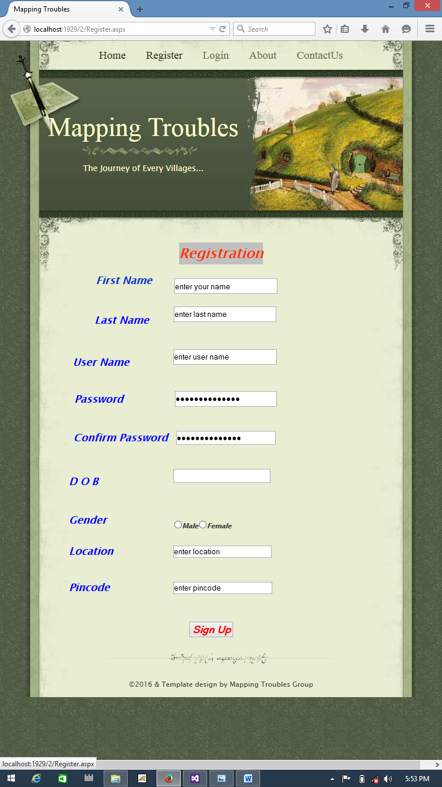

.
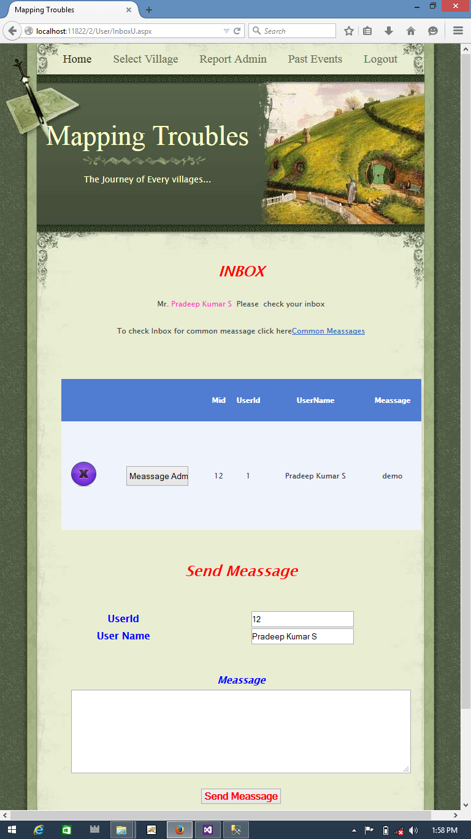

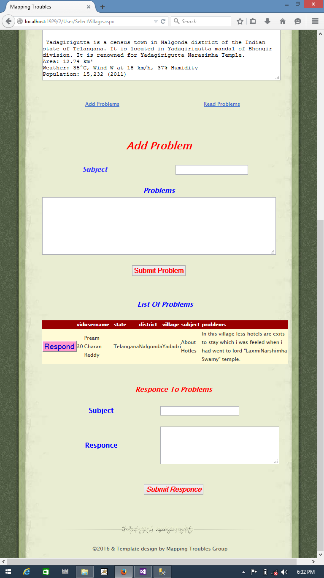

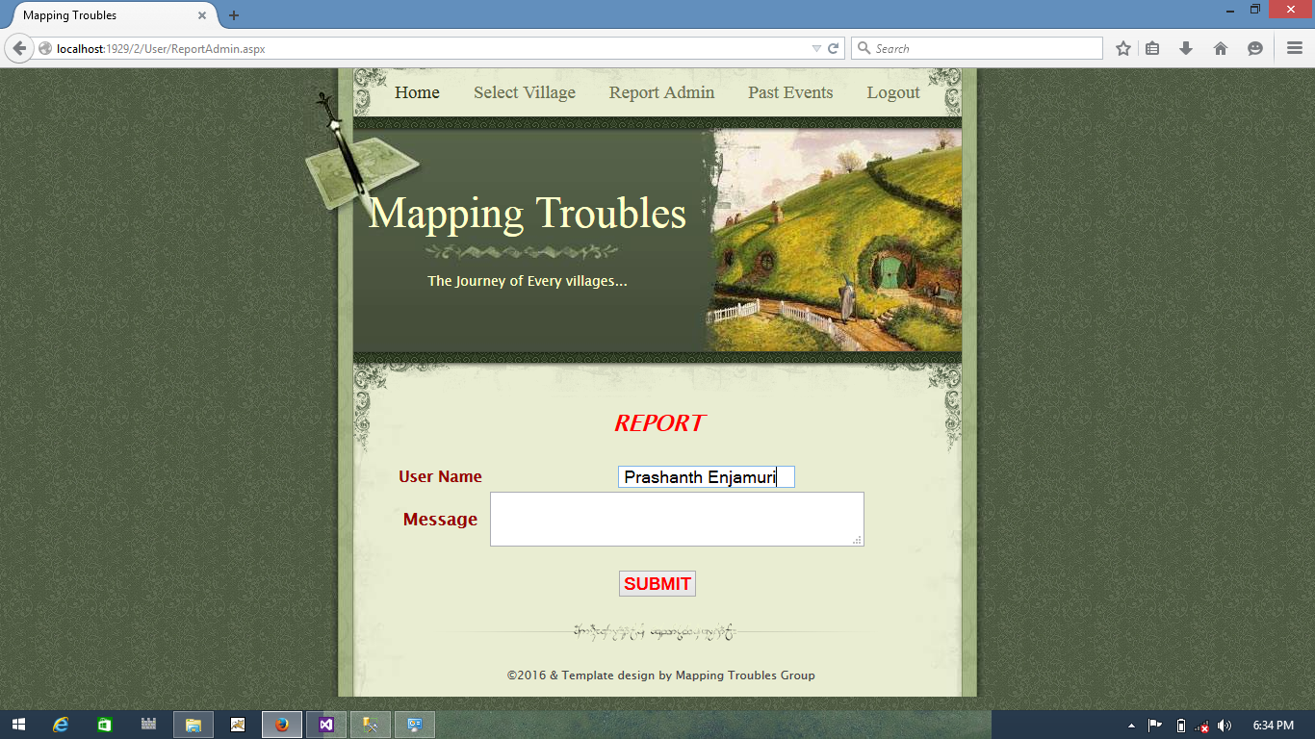

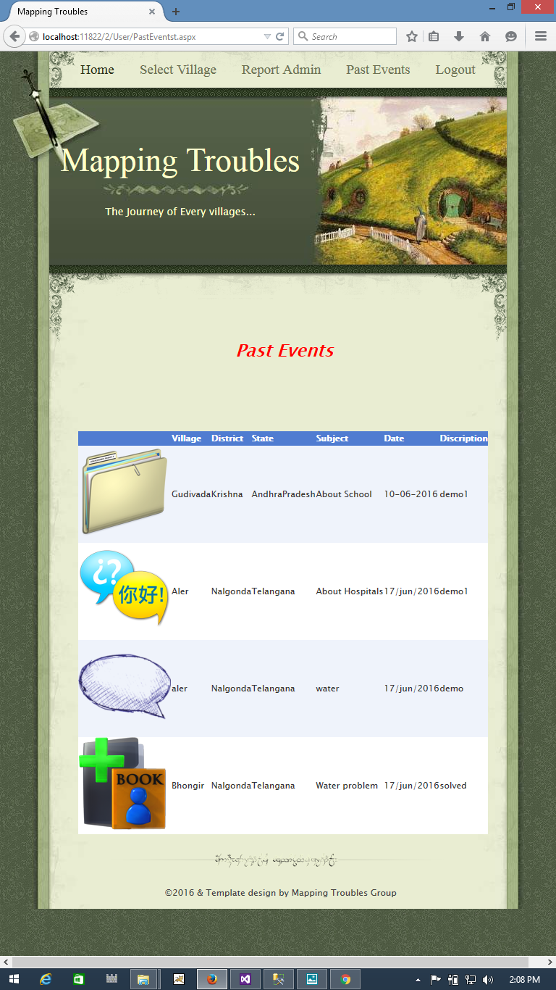
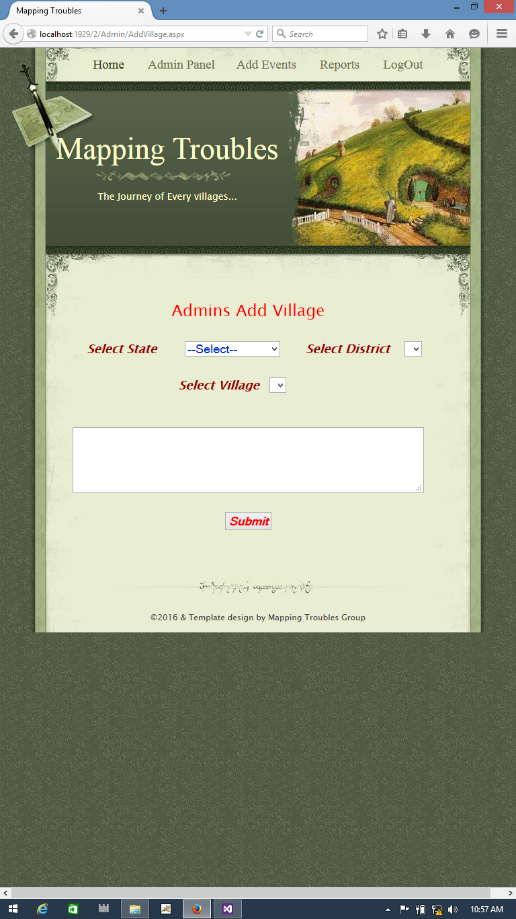
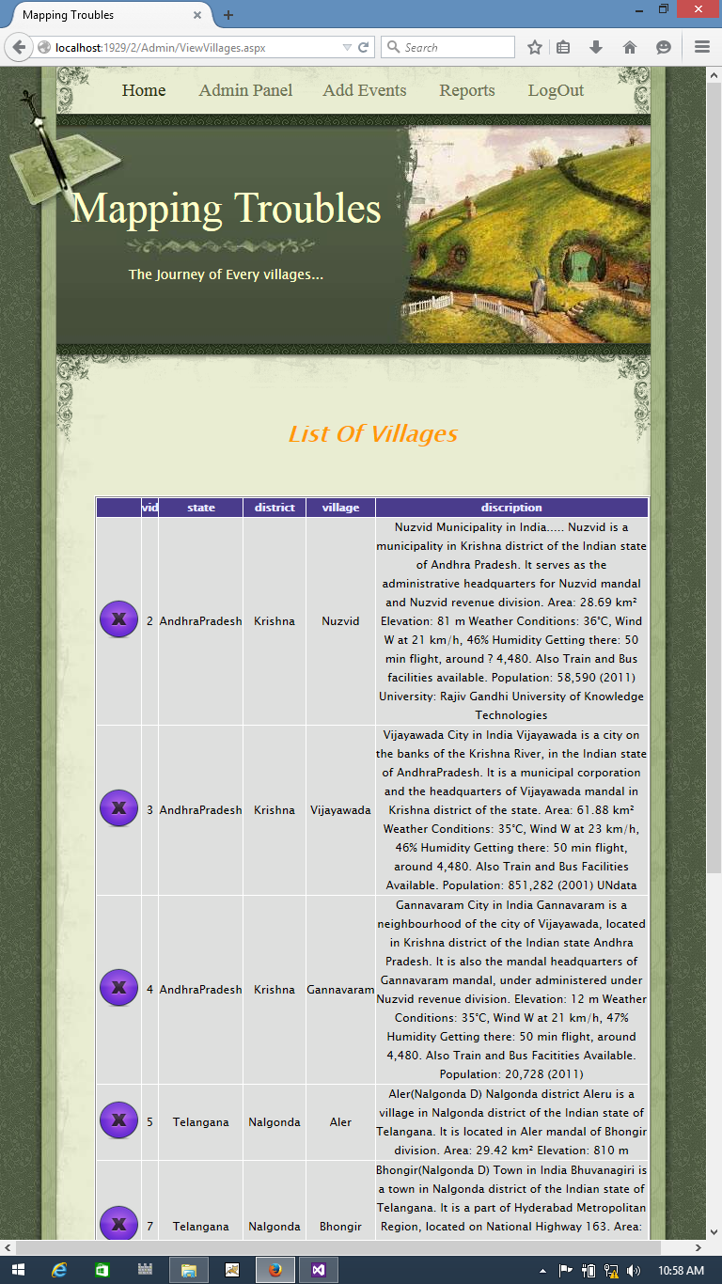
CONCLUSION:
1. Major Challenges for Rural Transformation Untapped Unemployment, Under- Lack of Conducive Low employment and seasonal Environment for Emerging Contribution employment , Low Opportunities Productivity in agriculture & Entrepreneurship in GDP for livelihood allied sectors Low Inadequate Low coverage and Large segment dependent on Social Productivity assistance under Agriculture, Small & Marginal Farmers , in Rain fed Low capacity to invest, low output Security NSAP Agriculture System Lack of Financial Low level of skill & Inclusion, Inaccessibility Inadequacy Poverty education, Low to credit, High lending of Credit Trap Productivity & rate by MFI and unsustainable Income informal source of finances Weak Local Institutions, low Poor connectivity and Poor public participation and Lack of marketing Infrastructure, Infrastructure Delivery democratic decentralization Lack of power & other Mechanism facilities.

2. Approach to Poverty reduction through Sustainable Rural Development1 Self Employment and wage Employment under various Rural Employment Development Programs.2 Sustainable Multilevel approach to increase investment in agriculture, watershed livelihood through development and empowerment of women through MKSP. Agriculture3 Focus of MGNREGA to create durable and quality assets . Durable Asset Connecting rural People with Banking system, Post offices and4 Financial Banking Correspondents (BC) for payments etc. Inclusion Promotion of proven technologies and best practices with multiplier5 Innovative Tech.& effects. Best Practices Rural Flexi-Fund to incentivize better performing States and6 managing the inequality of the region through better targeting and Flexi-Fund focused projects on state-specific priorities.

3. Rural management is the study of planning, organising, directing, and controlling of co-operatives, agribusiness and allied fields. It merges the knowledge of management studies and applying it in the rural context. Most of the courses are designed in such a way that the concepts taught in the class is applied in the real life through training in the rural areas through case-studies and interaction with the rural people .

9. FUTURE ENHANCEMENT

This Mapping Troubles web-enabled project can be modified based on users feedback. If any modification had to be done apart from current features you may create a new group for a village in which registered village members participates among these participants who is more active select that participant as a village volunteer, who has a right to communicate with admin directly and assign village development tasks to this volunteer. The volunteer should develop the village in an efficient manner.

10 BIBILIOGRAPHY
For .NET installation
www.support.microsoft.com
For deployment and packing on server
www.developer.com
www.15seconds.com
For SQL
www.msdn.microsoft.com
For ASP.NET
https://msdn.microsoft.com/en-IN/library/z1zx9t92.aspx
https://msdn.microsoft.com/enus/library/zw4w595w%28v=vs.110%29.aspx
https://msdn.microsoft.com/en-us/library/4w3ex9c2.aspx

Internet Drafts and RFCs
- DARPA RFC791, IP (Internet Protocol) http://www.ietf.org/rfc/rfc791.txt September 1981
- Simpson, W. RFC 1661 The Point-to-Point Protocol (PPP) http://www.cis.ohio-state.edu/cgi-bin/rfc/rfc1661.html July 1994
http://www.ietf.org/rfc/rfc2433.txt October 1998
- Pall, G. for Microsoft and Zorn, G. for Cisco RFC 3078 MPPE (Microsoft Point to Point Encryption protocol) http://www.faqs.org/rfcs/rfc3078.html March 2001
- Potter, D. & Zamick, J. for Cisco Systems PPP EAP MS-CHAP-V2 Authentication Protocol
http://www.ietf.org/internet-drafts/draft-dpotter-pppext-eap-mschap-01.txt January 2002

